**FARHA ASSOCIATION MODEL**

**Dictionnaire Des Données :**

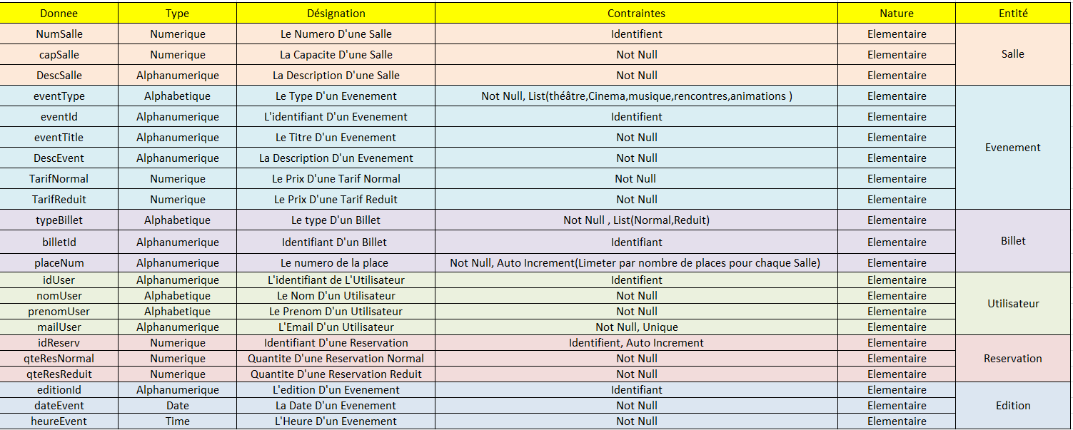

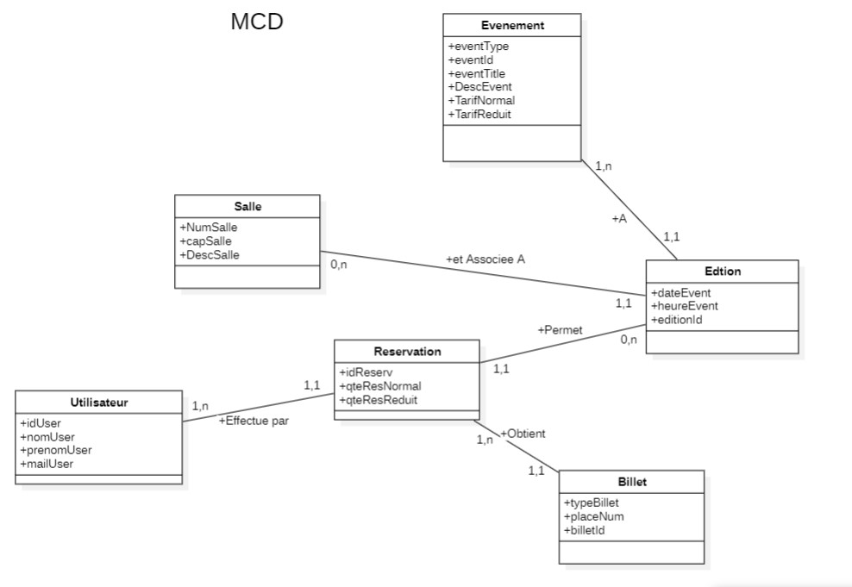

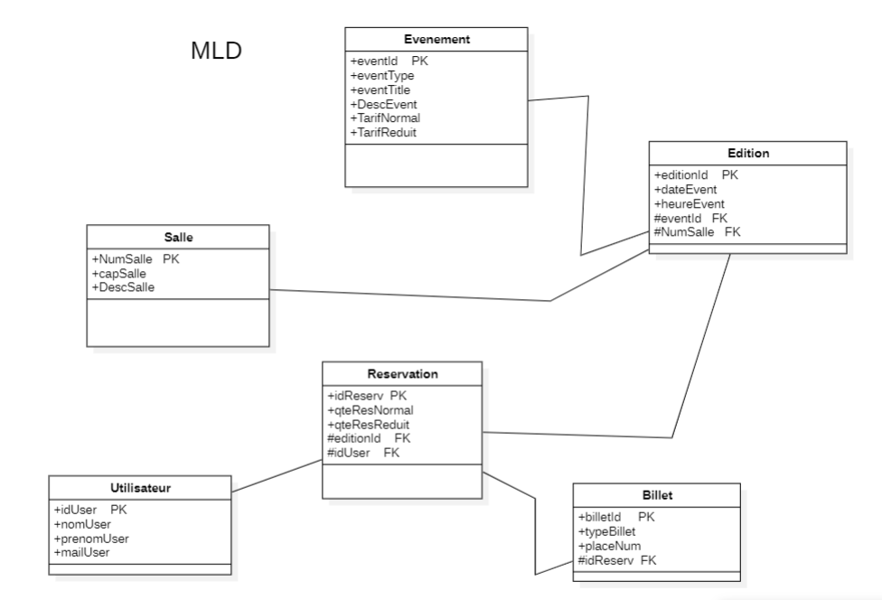

**SQL CODE :**

Create Database :

CREATE DATABASE FarhaEvents

-- Create the 'Evenement' table

CREATE TABLE Evenement (

eventId VARCHAR(30) PRIMARY KEY,

eventType VARCHAR(50) NOT Null,

eventTitle VARCHAR(100) NOT Null,

DescEvent TEXT NOT Null,

TariffNormal DECIMAL(10, 2) NOT Null,

TariffReduit DECIMAL(10, 2) NOT Null

);

-- Create the 'Salle' table

CREATE TABLE Salle (

NumSalle INT PRIMARY KEY,

capSalle INT NOT Null,

DescSalle TEXT NOT Null

);

-- Create the 'Utilisateur' table

CREATE TABLE Utilisateur (

idUser VARCHAR(20) PRIMARY KEY,

nomUser VARCHAR(30) NOT Null,

prenomUser VARCHAR(30) NOT Null,

mailUser VARCHAR(100) UNIQUE NOT Null

);

-- Create the 'Edition' table

CREATE TABLE Edition (

editionId VARCHAR(30) PRIMARY KEY,

dateEvent DATE NOT NULL,

heureEvent TIME NOT NULL,

eventId VARCHAR(30) NOT NULL,

NumSalle INT NOT NULL,

FOREIGN KEY (eventId) REFERENCES Evenement(eventId) ON DELETE CASCADE ON UPDATE CASCADE,

FOREIGN KEY (NumSalle) REFERENCES Salle(NumSalle) ON DELETE CASCADE ON UPDATE CASCADE

);

-- Create the 'Reservation' table

CREATE TABLE Reservation (

idReserv INT PRIMARY KEY AUTO_INCREMENT,

qteResNormal INT NOT Null,

qteResReduit INT NOT Null,

editionId VARCHAR(30) NOT Null,

idUser VARCHAR(20) NOT Null,

FOREIGN KEY (editionId) REFERENCES Edition(editionId) ON DELETE CASCADE ON UPDATE CASCADE,

FOREIGN KEY (idUser) REFERENCES Utilisateur(idUser) ON DELETE CASCADE ON UPDATE CASCADE

);

-- Create the 'Billet' table

CREATE TABLE Billet (

billetId VARCHAR(15) PRIMARY KEY,

typeBillet VARCHAR(50) NOT Null,

placeNum INT NOT Null,

idReserv INT NOT Null,

FOREIGN KEY (idReserv) REFERENCES Reservation(idReserv) ON DELETE CASCADE ON UPDATE CASCADE,

CONSTRAINT CheckType CHECK(typeBillet IN('Normal','Reduit'))

);